

**Parallel Technologies**

**Student**: Raghda Altamimi

**Program**: MSC. in Computer Science Engineering

**Neptune:** BXTOKA

**Lecturer**: Mr. Novak Peter

FACULTY OF ENGINEERING AND INFORMATION TECHNOLOGY

UNIVERSITY OF PÉCS

# Matrix-Multiplication:

[Matrix Multiplication](https://en.wikipedia.org/wiki/Matrix_multiplication) is such a central operation in many [numerical algorithms](https://en.wikipedia.org/wiki/Numerical_algorithm) much work has been invested in making matrix multiplication algorithms efficient. Applications for matrix multiplication in computational problems are found in many fields including [scientific computing,](https://en.wikipedia.org/wiki/Scientific_computing) Engineering and [pattern recognition](https://en.wikipedia.org/wiki/Pattern_recognition) and in seemingly unrelated problems such as counting the paths through a [graph.](https://en.wikipedia.org/wiki/Graph_(graph_theory)) Many different algorithms has been designed for multiplying matrices on different types of hardware,

including [parallel](https://en.wikipedia.org/wiki/Parallel_computing) and [distributed](https://en.wikipedia.org/wiki/Distributed_computing) systems, where the computational work is spread over multiple processors.

Algorithm:

* Input: matrices A and B
* Let C be a new matrix of the appropriate size
* For i from 1 to n:
* For j from 1 to p:
* Let sum = 0 • For k from 1 to m:
* Set sum ← sum + Aik × Bkj
* Set Cij ← sum
* Return 0

# Iterative Algorithm:

The definition of Multiple Matrix is that if C = AB for an n × m matrix A and an m × p matrix B, then C is an n × p matrix with entries

The product C of two Matrices A and B is defined as

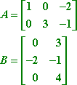

AB = [[ 0  -5 ][ -6  -7 ]]

# Results:

**2*2, 4*4, 6*6 , 12*12 Matrices**

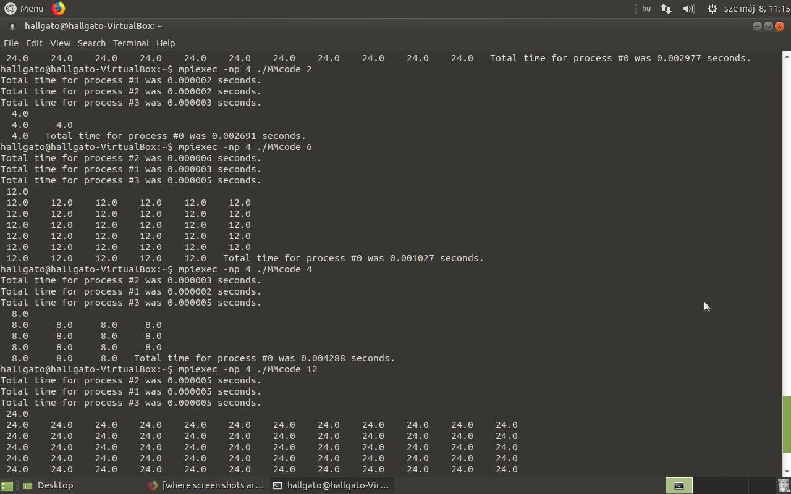

# References

<https://www.programmingsimplified.com/c-program-multiply-matrices>

<https://www.programiz.com/c-programming/examples/matrix-multiplication>